|  |
| --- |
| **Assignment 2 :** Application and management plan with project plan |

Admission No: 155135S

Name: Ashley Wong

1. **Project Overview**
   1. Goals and objectives

*\* Describe the goals and objectives of your project.*

*\* Mostly, goals are given by the company management so you can rewrite the goals in your term.*

Goal: Complete Game with Multiplayers features, and obtaining top 100 list in Google Play Store/ App Store in the first week of release.

Objectives: 6 month production period, Alpha in the 4th month. Close beta for pre-registered players 2 weeks before launch. Pre-registration available 1 month before launch (5000 players).

* 1. Unique selling point

Customisable characters. Real time team gameplay. Characters are player customised in which players can choose their abilities and army. Each player will have their choice of their faction and will be able to work with friends or other online players.

1. **Game**
   1. Game play

Gameplay would be a 3 vs 3 RTS game where players farm resources and build their armies within a certain time limit. The basic game would be five minutes of build time. After building army players will fight each other in an arena with their army.

* 1. Features and functions
* Real time multiplayer
* Large amount of customisation
* Large replay value
* Ability to play with friends while on the go
* In game purchases to buy new factions and skins(also unlockable using in game currency)

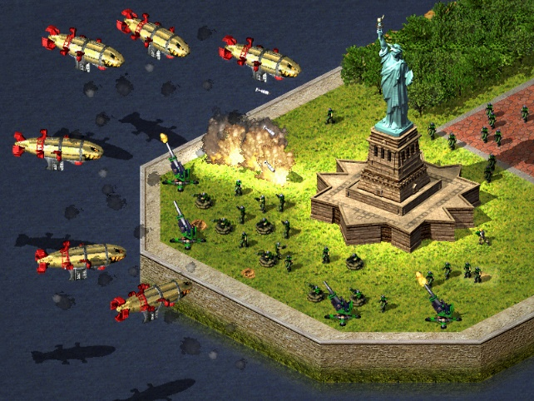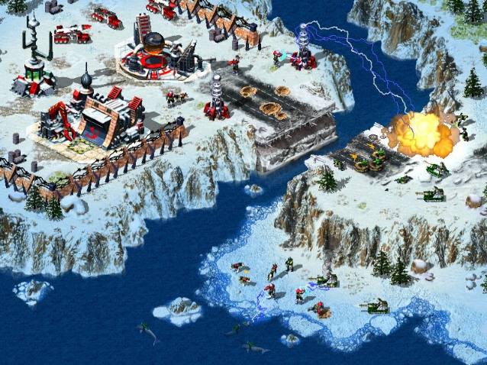

1. **Team Information**
   1. Number of each type of Members

* Artists: 5
* Programmer: 5
* Lead programmer: 1
* Project manager: 1
  1. Assigning roles
* Gameplay: 2 programmer + Lead programmer
* UI : 1 programmer
* Main menu: 1 programmer
* Game Art: 2 artist
* Main menu art: 1 artist
* Character design: 1 artist
* Icons: 1 artist
  1. Milestone & Schedule Estimation

|  |  |  |
| --- | --- | --- |
| Event | Duration | Completion |
| Completing core gameplay | 3 months | Ability to play a 3v3 game |
| Shop | 1 month | Able to purchase in game items |
| UI | 2 weeks | Completing the UI of the game |
| Multiplayer function | 1 month | Able for large amount of players to connect w/o issue |
| Alpha/Beta test | 1 month | Fix Core bugs and gameplay issues before launch |

1. **Agile Plan**

* Scrum meeting every day before working on the project.
* Sprints that last 2 weeks each.
* Having Sprint reviews before each sprint.
* Testing before implementing.
* Sprint backlogs.

1. **Remarks**

*\* Examples in below;*

* 1. *Challenges and Risks*
  2. *Remarkable Issues*